INDIAN INSTITUTE OF TECHNOLOGY PATNA

CS226- Switching Theory Lab

Lab 4: Logic simulation Sub-blocks

Assignment:

(Design and simulate)

In this lab, you will begin to familiarise yourself with some standard blocks. This will help you learn more about logic, and build the fundamental components used various architectures.

Assignment:

**P1:** Implement the function Y= wx'y'+yw'z'+yxz+yxw using basic gates

(5 points)

P2: Simulate the following the following (2-4 decoder).

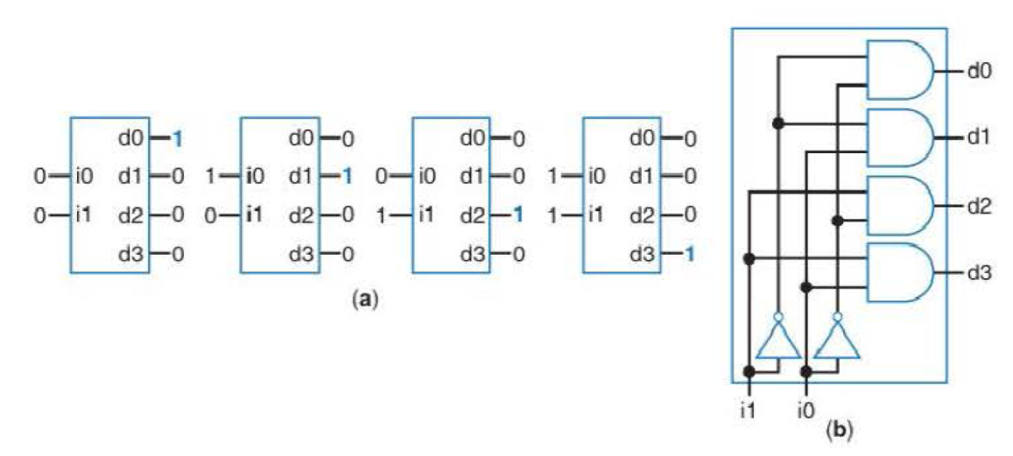

P3: Simulate the following the following (2-4 decoder).

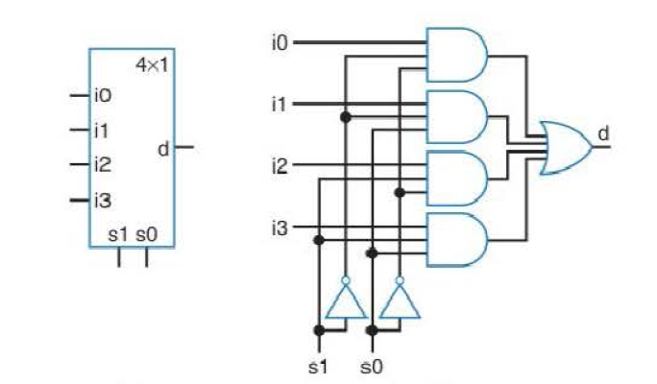

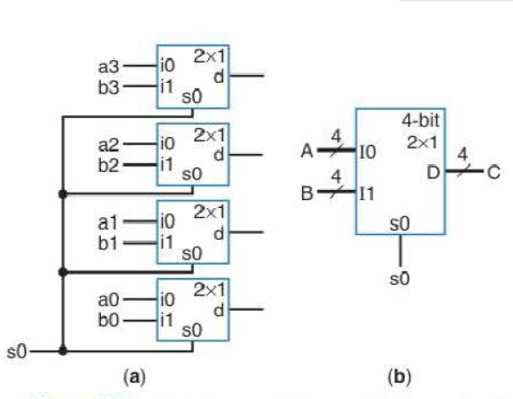

**P4:**

A home entertainment center has four different audio sources that can be played over the same set of speakers. Each audio source, named A, B, C and D, is connected using a wire on which the digitized audio signal is transmitted. The user selects which audio source is to be played using a rotary switch with four outputs, s0, s1, s2 and s3, of which exactly one will be ‘1’ at any given time. If s0 = ‘1’, the audio source A should be played, if s1 = ‘1’, the audio source B should be played, and so on. Create a digital circuit with a single output O that will output the user’s selected audio source. (Hint: A block schematic is shown)

(10 points)



**P5:** Design a circuit which can select between A or B ; Two 4-bit inputs, A (a3 a2 a1 a0), and B (b3 b2 b1 b0)

**6:** Extend p5 for Four numbers (A, B, C and D) .

**P7:**



P8:



**P9:**

Design and Simulate a half adder and full adder circuit and extend the circuit that will add two 2-bit binary numbers (use half adder and full adder logic).

Input: A= a1a0, B= b1b0,

Output: C S1S0: sum of inputs (6 points)

P10: Design a combinational circuit that forms the 2-bit binary sum *S*1*S*0 of two 2-bit numbers a1a0 and b1*b*0 . Do not use half adders or full adders,

Submission:

Submit your .circ file containing your various transistor-level/logic level implementations. Hardcopy of the submission is required for this assignment. Show the simulations to TAs.

* The simulation files p1.circ, p2.circ, p3.circ, p4.circ, p5.circ, p6.circ … p10.circ
* Zip the above files. Zip; file name is your role number.

Course work submission through Email: [cs225.iitp@gmail.com](mailto:cs225.iitp@gmail.com)

(use email subject Lab4_Logicsim_your roll number).

This work is due on: : 29th Jan.